NAME : Suganthan Kumaresan

REG NO: 192424105

1. Design a lexical Analyzer to validate operators to recognize the operators +,-,\*,/ using regular Arithmetic operators .

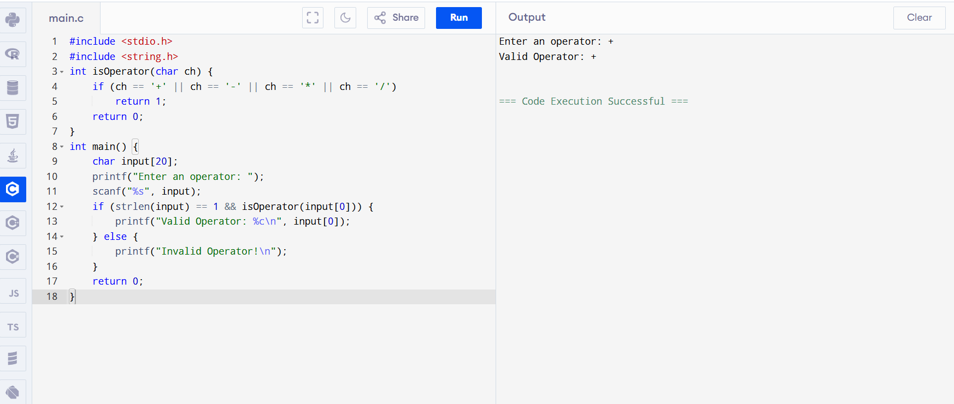

1. Design a lexical Analyzer to find the number of whitespaces and newline character
2. 